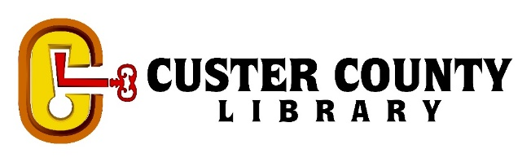
LENDING AND FEE POLICY
The main goal of the CCL lending and fee policy is to offer transparent guidelines regarding the borrowing duration and usage parameters for library materials. Additionally, we aim to provide a clear breakdown of any fees associated with library services.
LENDING AND FEES
 | LOAN PERIOD | AUTOMATIC RENEWALS* | MAY PLACE HOLDS | REPLACEMENT FEE† | PROCESSING FEE
Books | 3 weeks | 1 renewals of 3 weeks | Yes | Cost of Item | $5 per item
Magazines | 3 weeks | 1 renewals of 3 weeks | Yes | Cost of Item | $5 per item
Interlibrary Loan | Determined by lending library | No | Yes | Lending Library Cost | $5 per item
Videos | 1 week | 1 renewals of 1 week | Yes | Cost of Item | $5 per item
Puzzles | Bring back when you are finished. |  | No | None | None
Audiobooks | 3 weeks | 1 renewals of 3 weeks | Yes | Cost of Item | $5 per item
eBooks | 7 day, 14 day, or 21 day- determined by patron | According to vendor | Yes | None | None
Park Passes | 3 days | No | No | Custer State Park Cost | $5 per item
Early Learner Kits | 2 weeks | No | Yes | Cost of Items | $5 per kit
Laptop/ Tablet | In House Use Only | No | No | Cost of Item | $5 per item
Projector | In House Use Only | No | No | Cost of Item | $5 per item
Cricut Maker 3 | In House Use Only | No | No | Cost of Item | $5 per item

*Renewals may be restricted if there are holds on the item or if there is an account block in place.
†Items in new condition may be donated instead of paying replacement fees, however, a processing fee remains applicable. In cases of personal emergencies such as bereavement, hospitalization, accidents, fires, theft, or financial distress, library staff will exercise discretion in waiving charges for lost materials. Any waived fees will be documented in the patron's record.
‡Cost of Item is the list price from library vendors at the time of replacement.

MISCELLANEOUS FEES
SERVICE | NOTES | FEE
Non Resident Card | May be used by immediate family. Expires each year on sign-up anniversary. *Libby access not available. | $35/ Year
Wi-Fi | Available 24/7. No Password required in Custer. | Free
Computer Use | Two 30 minute sessions per day. May be taken consecutively if no one is waiting. | Free
Photo Copier | Reduce, enlarge, duplex. 100 copy limit on B&W per day. | B&W $0.10 per side. Color $1.00 per side
Printer | A printer is connected to the desktops for printing. | B&W $0.10 per side. Color $1.00 per side
Interlibrary Loan | Ask for more Information. | Free * Donations accepted for postage
Electronic Resources | Available at www.library.sd.gov | Free Ask for more Information
Restricted Reference Materials | Photocopies can be made of materials not-for-loan. | Free
Study Room | The room is available for use in two-hour increments. A fee will be charged if the room is utilized for profit-oriented purposes. | $5 per session for-profit purposes
Meeting Room | Free access is provided to non-profit organizations, while for-profit groups are subject to a rental fee. | $10 per hour for-profit purposes
Programming Room | The availability of the Programming room is subject to the discretion of library staff. | $25 per hour

ACCOUNT BLOCKS
Access to patron computers in the library and online books and audiobooks via Libby will be restricted if fees exceed $10. Additionally, accounts with overdue items exceeding 30 days will have restrictions placed on them until the items are returned or the fees are settled. Furthermore, accounts that are expired, manually blocked, or flagged for verification by library staff will also be subject to restrictions.

