Custer County Library Foundation
Meeting Minutes December 14, 2023
Custer Library

Call to Order: The Custer County Library Foundation (CCLF) meeting was called to order Thursday, December 14, 2023, at 1:00 by President Rose Kor. Council members in attendance; Rose Kor, Katherine Wakefield, Laura Burns, Kim Canete, Cheryl Dillon (via zoom) and Library Director Sarah Myers.

Agenda Review: President Rose presented the agenda for the meeting with no changes.

Minutes of October 19, 2023 Meeting: The minutes from the meeting were reviewed electronically prior to the meeting. The meeting minutes were accepted as presented.

Treasurer's Report:
Katherine sent her report and spreadsheets electronically for review pre-meeting with the summary below:
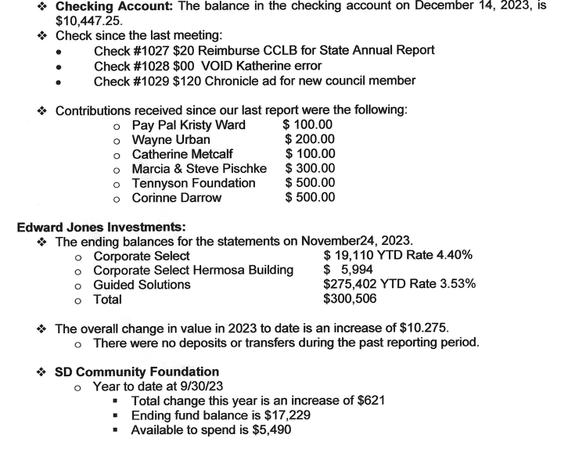
Discussion about the Lynn's Dakotamart receipts resulted in the decision that CCLF will not do any tracking of these and all funds will be deposited in the Library general checking account.

Library Board and Librarian Report:
- Susan Swindal is the newly approved Library Board Member.
- The State library accreditation status continues to be Exemplary for the next three years thanks to the hard work of the Library Board and the Library Staff. Congratulations.
- Sarah mentioned there were some additional costs for travel and advertising for which she requested funding and were approved by the County Commission.
- Sarah attended the Library consortium meeting where library cards were a discussion item. Cards will be in a three-year renewal cycle with the date of birth required on them.
- Staff are working to update library polices and streamline the website.
- Discussions have begun for the 2024 Summer Reading Program
- A Grant Writing Seminar was well presented and very helpful for future applications.

Unfinished Business:
- Nomination/Application for Foundation Council
Two letters of interest were received. After discussion, Kim made a motion, second by Cheryl, to accept Audrey Alfson as the new Foundation Council member.
.
- 2023 Fall Newsletter
The Newsletter was completed with 250 copies printed. The group met last month, November 15, to configure the new donation envelope for inclusion with the newsletter. Stamps and address labels will be affixed today and the 2023 Newsletter will be mailed.

New Business
- Cooperative Project with Custer Mile High Garden Club
Jenny Behlings has been getting seed donations from the Herman's Garden Seed Donation Program as an outreach of the Custer Garden Club. They have requested support from the Library Foundation with our non-profit status. After discussion Katherine made the motion, Kim second, to have CCLF join in Partnership with the Custer Mile High Garden Club specifically for the Herman's Garden Seed Donation Program and to use the CCLF tax-exempt authority on the Grant Application. Motion Approved.

- Annual Meeting - January 11, 2024, 1:00 p.m.
Meeting date set and agenda items will include:
-Edward Jones Investment presentation -Annual Financial Review
-Seat the new Council Member-Audrey Alson -Election of Officers
-Transfer Secretary Duties
President Kor adjourned the meeting at 2:06 p.m.

Laura Burns
Secretary

Attachments: Agenda, Checking Account Statement Spreadsheet, Edward Jones Investment Summary Sheet, SD Community Foundation Summary, Foundation Council Letters of Interest, Newsletter

